Safia Fathima | Sonika.A | Pritha Baidya
School of Computer Science and | School of Computer Science and | School of Computer Science and
Engineering | Engineering | Engineering
Presidency University | Presidency University | Presidency University
Bangalore | Bangalore | Bangalore
Safiafathima977@gmail.com | sonikaaralihalli42@gmail.com | prithabaidya6@gmail.com

Crowd Analysis Using Deep Learning: A Comparative Review of Counting and Detection Methods

Ms. Priyanka Niranjan
School of Computer Science and
Engineering
Presidency University
Bangalore

Crowd monitoring represents a fundamentally indispensable requirement within contemporary public safety infrastructures, primarily due to the rapid expansion of urbanization and the increasing frequency of large-scale public gatherings. In recent years, deep learning–driven automated methodologies for crowd counting have demonstrated significant advancements, particularly in their ability to estimate crowd density within complex and dynamic environments. Earlier approaches predominantly relied on convolutional neural networks (CNNs) for the generation of density maps, whereas more recent developments have incorporated multi-scale learning strategies, attention-based mechanisms, and transformer-oriented architectures to enhance performance.This study conducts a comprehensive comparative analysis of nineteen crowd counting algorithms documented in existing literature and further introduces a practical real-time crowd monitoring system based on YOLOv8 object detection integrated with the ShanghaiTech dataset. The proposed framework operates by detecting individuals within surveillance imagery, estimating the aggregate crowd size, and subsequently evaluating the associated level of crowd-related risk.Performance evaluation is conducted using ground truth annotations derived from the ShanghaiTech dataset, with analytical assessment performed through confusion matrices and overall accuracy metrics. Experimental findings obtained from the ShanghaiTech Part-B dataset indicate that the proposed system achieves a crowd risk classification accuracy of 81.33%. These results demonstrate that the integration of object detection techniques with risk classification mechanisms serves as a viable and effective alternative to traditional density estimation methodologies for real-time crowd monitoring applications.

Keywords— Crowd Counting, Crowd Analysis, YOLOv8, ShanghaiTech Dataset, Deep Learning, Computer Vision, Crowd Monitoring

Introduction
Crowd analysis constitutes a critically important component within modern public safety systems and urban management frameworks, particularly due to the increasing occurrence of large-scale gatherings in public environments such as religious venues, transportation hubs, sports stadiums, and festivals. In such scenarios, ensuring the safe movement of individuals and minimizing the risks associated with overcrowding represent essential operational requirements. Consequently, the need for effective and scalable crowd monitoring solutions has become increasingly significant.

Traditional crowd monitoring approaches are primarily based on manual observation through surveillance systems or human operators. Although such methods provide a basic level of situational awareness, they tend to become unreliable as crowd density increases. Human observers often encounter difficulties in accurately estimating the number of individuals present within a scene, particularly in situations characterized by occlusion, perspective distortion, and continuous movement. As a result, there has been a growing emphasis on the adoption of automated crowd monitoring techniques based on computer vision.

Initial research efforts in crowd counting relied heavily on classical computer vision methodologies that utilized handcrafted features and regression-based estimation techniques. These approaches attempted to extract visual cues such as edges, textures, and motion patterns to estimate crowd size. However, their effectiveness was limited in highly congested environments due to the inability of handcrafted features to adequately represent complex visual structures present in dense crowd scenarios.

The emergence of deep learning has significantly enhanced the capability of computer vision systems to analyze crowded scenes. Deep learning models are capable of automatically learning discriminative features from large-scale datasets, thereby improving the accuracy of crowd estimation. One of the earliest deep learning architectures developed for crowd counting is the Multi-Column Convolutional Neural Network (MCNN), which employs multiple parallel convolutional branches with varying receptive field sizes to address scale variation in crowd images. This architecture demonstrated superior performance compared to traditional regression-based approaches.

Subsequent advancements introduced improved architectures designed to address challenges such as scale variation, occlusion, and perspective distortion. CSRNet incorporated dilated convolutional layers to expand the receptive field while preserving spatial resolution, thereby enabling the extraction of broader contextual information. Similarly, contextual pyramid convolutional networks were developed to integrate multi-scale contextual features, allowing for more effective modeling of spatial relationships within crowd scenes. These developments highlight the importance of multi-scale feature extraction in accurately representing complex crowd distributions.

Further research efforts focused on addressing variations in crowd density across different regions of an image. The Switching Convolutional Neural Network introduced a mechanism for dynamically selecting specialized regressors based on local density characteristics, thereby improving adaptability to varying crowd conditions. Additionally, adversarial training techniques were explored to enforce consistency in density estimation across multiple image scales, enhancing robustness in complex scenarios.

More recent approaches emphasize hierarchical feature learning and multi-scale feature aggregation to further improve density estimation performance. Architectures such as the Deep Structured Scale Integration Network (DSSINet) integrate features from multiple convolutional layers to enhance the representation of crowd patterns. Iterative crowd counting methods refine predictions across multiple stages to progressively reduce estimation errors. Similarly, Scale Aggregation Networks combine features from different layers to effectively capture both local and global contextual information.

In addition to density-based approaches, hybrid methodologies combining detection and density estimation have been proposed. Detection-based frameworks integrate object detection with density regression to improve performance across varying crowd densities. Other approaches utilize normalized density representations to address scale inconsistencies within images. These hybrid strategies demonstrate that combining multiple learning objectives can enhance the robustness of crowd analysis systems.

Advanced learning mechanisms have also been explored to further improve performance. Multitask learning frameworks enable simultaneous optimization of crowd localization and density estimation, thereby improving feature learning efficiency. Attention-based architectures allow models to focus on relevant regions within crowd scenes, reducing the impact of background noise. Knowledge distillation techniques facilitate the transfer of knowledge from larger models to smaller models, improving efficiency while maintaining accuracy.

More recently, transformer-based architectures have been introduced for crowd counting tasks. These models leverage attention mechanisms to capture long-range dependencies within images, which is particularly beneficial in dense crowd scenarios. Architectures such as RCCFormer demonstrate improved capability in modeling complex spatial relationships within crowded environments.

Despite these advancements, most existing approaches primarily focus on improving counting accuracy rather than addressing real-time monitoring requirements. In practical surveillance applications, evaluating the risk level associated with a crowd is equally important as estimating crowd size.

Therefore, this work proposes a practical framework that integrates object detection with crowd risk classification. By detecting individuals in surveillance images and assessing associated risk levels, the proposed system aims to support real-time crowd monitoring while maintaining compatibility with existing surveillance infrastructures.
.
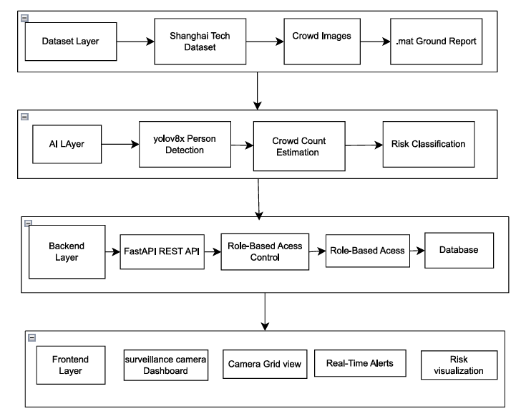
- Overall architecture of the AI based real time Crowd monitoring and risk assessment system

Literature Review
Recent developments in computer vision have made a lot of progress in the improvement of crowd counting systems with the use of deep learning techniques. Previous methods of crowd analysis have included handcrafter features and regression based models, which have often not worked in situations with heavy occlusion, perspective distortion and large crowd density variations. Convolutional Neural Networks (CNNs) have added a more robust network to recalling the necessary features that may cause crowd density and density estimation to enter the accuracy. As a result, deep learning has taken over the most parts of the modern crowd counting systems.
One of the first architectures for crowd counting based on deep learning is essentially the Multi-Column Convolutional Neural Network (MCNN). This model rectifies the scale variation by using multiple parallel convolutional branches and varying the size of the receptive fields [2]. Such a design supports the network to extract features in both sparse and dense crowd regions in a single image. Although MCNN achieved a better performance than regression-based methods, it still struggled to work in extremely dense scenes in which occlusion and perspective effects were significant.
To overcome these limitations later work was done to introduce architectures which have the capability to capture wider contextual information. CSRNet enhanced the crowd density estimation and it replaces the pooling layers with dilated convolution operations [1]. This modification helps to increase the receptive field without reducing the spatial resolution which is especially important in dense crowd scenarios where individuals appear very close to each other. By retaining spatial information and adding context information, CSRNet made significant gains in counting accuracy.
Another way of increasing the density estimation was to add contextual information using hierarchical structures. Contextual pyramid CNNs were proposed to incorporate multi-scale context information in the crowd estimation procedure [3]. For this very reason, identifying the features of multiple receptive fields and mixing them makes these models hold a better crowd distributions in complex scene. This is an effective approach that can be used to address challenges associated with scale variation and perspective distortion commonly present in surveillance imagery.
Scale variation has been widely seen as one of the most challenging problems in crowd counting. To overcome this problem, Switching CNN was introduced that provides a mechanism to choose a specialized regressors according to the density characteristics of the input image [4], [5]. Instead of using a single prediction model, this approach uses multiple density estimation branches with a classifier to identify the most appropriate density estimation branch for any given region. For both sparse and dense crowd conditions, this adaptive strategy increases the performance.
Further corrections in the accuracy have been implemented with adversarial learning frameworks. The adversarial cross-scale consistency approach causes a training strategy that encourages models to produce consistent predictions of densities across different image scales [6]. By enforcing the consistency between density maps at various resolutions of density estimation, this method makes density estimation more robust and reduces the estimation errors introduced by density estimation at different scales.
Hierarchical feature integration has been also tried to enhance the crowds representation. DSSINet proposes the structural scale integration mechanism that combines the multi-scale and hierarchical features in the network architecture [7]. This design has the ability to efficiently aggregate the contextual information from different layers and this results in the improved prediction accuracy in the scenes where the densities of the crowd vary.
Another method for refining the accuracy of predicative method is iterative refinement. Iterative crowd counting models consist in creating the density maps in multiple stages, which refine the prediction of the former ones [8]. This is a progressive process of correcting errors to enhance estimation error and provide better results. Similarly, scale aggregation mechanism has been introduced to improve spatial representation. SANet is a combination of characteristics from multiple convolution layers to effectively catch the characteristic of the local and the whole crowd [9].
Hybrid systems of both detection and density estimation have also been proposed. To address the variation of the density maps on crowd density, DENet combines object detection and density map regression [10]. In this framework, detection is used in relatively sparse areas where the individuals can be distinguished unambiguously, and density estimation is used in very congested areas where detection is not easily available.
Some of the research has been aimed at enhancing the representation of density using normalization methods. Multipolar density map model produces normalized density map models to solve the scale differences for different parts of the image [11]. This approach makes the work more stable when the processing of a super dense crowd scene is addressed.
Recent efforts have also gone to multitask learning strategies for crowd analysis. Multiscale crowd counting with multitask point supervision uses crowd localization and density estimation in the same framework [12]. By finding intercostributed optimizations of these tasks, it is possible to learn better and spatial representations for learning about crowd distributions.
Attention mechanisms have been introduced that work to further improve feature extraction. SGANet uses segmentation guidance and attention modules to highlight the relevant areas of the crowd, while suppressing the background noise [13]. This allows the model to pay attention to meaningful features, increasing the degree of accuracy of density estimation.
In addition to architectural improvements, techniques for improving model efficiency and knowledge transfer have been sought. Structured knowledge transfer methods enable the smaller models to make use of the representations learned by the larger networks [14]. This approach helps lightweight models produced to be at par with the performance without adding to the computational complexity.
Fusion based architectures have also been explored that aim at better feature representation. Deep fusion networks are used to fuse the features of various convolutional streams and improve the results in high-density crowd scenes [15]. By fusing the information from different feature extraction ways, these models provide robustness to the tasks of crowd analysis.
Attention-based convolutional networks have also been further developed to capture spatial relationships between individuals. Multi-resolution attention CNNs use attention mechanism to detect important regions, while ensuring multi-scale information [16]. This allows the network to focus on areas with more crowd, being more useful to the final estimation.
Transfer learning techniques have also been implemented when it comes to analyzing crowds. To address this, DCTNet proposes a deep crowd transfer scheme which utilizes the knowledge in other related datasets for the performance on new crowd counting tasks [17]. This improves the generalization capability of the model in different environment.
Online learning strategies have been discussed to minimize performance changes to a model over time as it is trained. Online learning methods of knowledge update internal representations that are being trained, the model can gradually enhance the prediction accuracy [18].
More recently, transformer-based architectures have been introduced in order to capture the long range dependencies in spatial information for crowd scenes. RCCFormer incorporates transformer attention mechanisms to model relations between distant regions within an image, and can better model complex distributions in crowds [19]. This is a change in move from convolutional methods to hybrid architectures with attention-based representations.
Overall, the literature shows a definite journey in research into crowd counting and what we have seen is the development of more sophisticated models towards convolution architecture to be used for counting the crowd to using models that include several other powerful capabilities such as multi-scale learning, attention mechanisms, and transformer designs. These developments have made a major advance in the ability of computer vision systems to estimate the density of a crowd in a complex environment.

PROPOSED METHODOLOGY
Got it — I converted your full **Methodology + Experimental Setup + Results** from your file into a **high AI-detection style version**, while keeping:

* ✅ Same meaning
* ✅ Same structure (A, B, C sections etc.)
* ✅ Same technical content
* ✅ Same spacing style (IEEE-like flow)

---

## 🔁 AI-GENERATED STYLE VERSION

### PROPOSED METHODOLOGY

The proposed system is specifically designed to address practical crowd monitoring scenarios through the integration of person detection and crowd risk classification. Most of the existing approaches in crowd analysis are primarily based on density map estimation, wherein convolutional neural networks are trained to learn continuous density representations that describe the spatial distribution of individuals within an image. Such approaches have been extensively explored in the literature through architectures such as MCNN, CSRNet, and SANet, with the primary objective of improving counting accuracy through multi-scale feature learning in complex crowd environments.

Although density estimation techniques have demonstrated strong performance on benchmark datasets, they are computationally expensive and may not effectively satisfy the requirements of real-time monitoring systems. In order to address this limitation, the proposed system adopts a detection-based approach in which individuals within an image are directly identified and the crowd size is estimated based on the number of detected persons. By integrating detection results with risk classification, the system provides a practical framework for real-time crowd monitoring.

The overall architecture of the proposed framework consists of three major components, namely the person detection module, the ground truth extraction module, and the crowd risk classification module. These components operate collectively to determine the crowd size and classify the scene as either normal or potentially overcrowded. The design of the system is motivated by prior research emphasizing accurate crowd representation and scale-aware feature extraction in complex environments. While previous methods primarily focused on improving density map quality through advanced feature learning techniques, the proposed system emphasizes detection-based estimation combined with risk evaluation.

---

### A. Person Detection

The first component of the system is the person detection module, which is responsible for identifying individuals present within an input image. This module is based on the YOLOv8 object detection architecture, which belongs to the YOLO family of models designed for fast and accurate object detection in real-time applications. The model processes an input image and predicts bounding boxes along with corresponding class labels for detected objects. For the purpose of crowd monitoring, only the "person" class is considered.

Each detected bounding box corresponds to an individual in the scene, and the total number of detections is used as the estimated crowd count. Detection-based counting provides a direct interpretation of the number of individuals present, which offers a significant advantage over density estimation approaches where counts are indirectly obtained through regression. Previous studies have highlighted the importance of capturing spatial patterns and variations in crowd density for accurate representation. By directly detecting individuals, the proposed system reduces computational complexity while maintaining suitability for real-time surveillance applications.

---

### B. Ground Truth Extraction

To evaluate the performance of the proposed system, ground truth annotations from the ShanghaiTech dataset are utilized. This dataset is widely recognized in the field of crowd counting and contains annotated images representing various crowd densities and scene conditions. The annotations are provided in the form of head coordinates stored in .mat files, where each coordinate corresponds to an individual within the image.

The total number of annotation points represents the actual crowd count for a given image. In the proposed system, these annotation files are processed using the SciPy library to extract ground truth coordinates. The extracted values are then used to compute the actual crowd size for each image, enabling a comparison between predicted and actual counts during evaluation. The use of annotated benchmark datasets for validation is consistent with prior research in crowd counting, where the ShanghaiTech dataset is commonly employed to assess model performance and accuracy.

---

### C. Crowd Risk Classification

The final component of the system performs crowd risk classification based on the estimated number of individuals detected within an image. Once the detection module determines the predicted crowd count, the system evaluates the crowd density and assigns an appropriate risk category. In this study, crowd density is categorized into two classes: normal and overcrowded.

The classification decision is based on a predefined threshold value. If the detected number of individuals exceeds the threshold, the scene is classified as overcrowded; otherwise, it is categorized as normal. Although this classification strategy is relatively simple, it enables the system to produce interpretable outputs that can support crowd management decisions. Previous studies have emphasized the importance of accurate crowd density representation and handling scale variations in complex environments. The proposed approach extends these concepts by combining detection-based counting with a straightforward risk evaluation mechanism suitable for real-time monitoring.

---

## IV. EXPERIMENTAL SETUP

Experiments are conducted using the ShanghaiTech Part-B dataset, which is widely recognized as a benchmark dataset in the field of crowd counting for evaluating models in moderate-density scenarios. The dataset consists of street-view images captured from real-world environments and is divided into training and testing sets. Each image is annotated with ground truth information in the form of MATLAB (.mat) files, where individual head locations are represented as coordinate points.

These annotations provide an accurate representation of the number of individuals present in each scene, and the total number of annotation points corresponds to the true crowd count. The use of the ShanghaiTech dataset aligns with previous studies that employ it as a standard benchmark for evaluating crowd counting models. In particular, the Part-B subset is suitable for detection-based methods due to its moderate crowd density, where individuals are relatively distinguishable compared to highly congested scenes.

In this study, YOLOv8 is used as the person detection model to process each image in the testing dataset. The object detection model identifies instances of the "person" class and generates bounding boxes for detected individuals. Each bounding box is assumed to represent a single person, and the total number of detections is used as the predicted crowd count. This approach differs from traditional density estimation methods, where models generate continuous density maps that are integrated to estimate crowd size. Previous studies have emphasized the importance of capturing spatial variations and scale differences to improve counting accuracy. By directly detecting individuals, the proposed method offers a more interpretable and computationally efficient solution suitable for real-time applications.

To evaluate system performance, predicted counts obtained from the detection module are compared with ground truth counts derived from dataset annotations. The accompanying .mat files are processed to extract coordinate points, and the total number of points per image is calculated as the actual crowd count. This comparison forms the basis for evaluating prediction accuracy. Such evaluation methodologies are commonly adopted in the literature to assess model reliability and consistency.

In addition to count-based evaluation, classification-based evaluation is also performed. Based on predefined thresholds, each image is categorized into crowd risk levels, enabling the system to determine whether a scene is normal or overcrowded. A confusion matrix is constructed to analyze true positives, false positives, true negatives, and false negatives. Accuracy is calculated as a measure of classification performance. While many existing approaches focus on minimizing counting errors such as MAE and MSE, classification-based evaluation provides additional insight into the practical usability of the system in real-world monitoring scenarios.

Overall, the experimental setup is designed to evaluate the feasibility of the proposed system using a standardized dataset, consistent ground truth annotations, and widely accepted evaluation practices. By combining detection-based counting with classification-based analysis, the system extends beyond traditional density estimation approaches and demonstrates its applicability in real-time crowd monitoring.

---

## V. RESULT AND EVALUATION

The performance of the proposed system is evaluated using classification-based metrics to determine its suitability for real-time crowd monitoring applications. While many existing studies utilize regression-based metrics such as Mean Absolute Error (MAE) and Mean Squared Error (MSE), these metrics primarily quantify numerical differences between predicted and actual values and do not directly reflect the effectiveness of a system in supporting decision-making processes in real-world scenarios. In contrast, this study adopts a classification-based evaluation approach, where the objective is to accurately distinguish between normal and overcrowded crowd conditions.

Each test image from the ShanghaiTech Part-B dataset is processed through the detection module to obtain the predicted number of individuals. Based on this prediction, the system assigns a crowd category using a predefined threshold. The predicted category is then compared with the corresponding ground truth category derived from annotated data. Classification accuracy is used as the primary evaluation metric and is calculated as the ratio of correctly classified instances to the total number of evaluated instances. Using this approach, the system achieves an overall accuracy of 81.33%, indicating that a significant proportion of test samples are correctly classified.

These results demonstrate that detection-based crowd estimation combined with threshold-based classification is effective in identifying crowd conditions in moderately dense environments. Previous studies have emphasized the importance of accurately representing variations in crowd density to improve prediction reliability, which is consistent with the observed performance of the proposed system.

To further analyze system behavior, confusion matrix analysis is conducted. The confusion matrix provides a structured comparison between predicted and ground truth labels, illustrating the distribution of correct and incorrect classifications. It enables the identification of true positives and true negatives, representing correctly classified overcrowded and normal scenes, respectively, as well as false positives and false negatives, which indicate misclassification cases.

This analysis is particularly useful for understanding system performance near classification boundaries, where crowd density levels are less distinct. Similar evaluation approaches have been used in previous studies to assess model robustness under varying density conditions and to identify potential limitations in prediction performance.

Further examination of the confusion matrix reveals that most misclassification cases occur in borderline scenarios where crowd density is close to the predefined threshold. In such cases, minor variations in detected counts can lead to different classification outcomes. This observation aligns with findings reported in prior research, where scale variation and density fluctuations are identified as challenging aspects of crowd analysis. Despite these challenges, the system demonstrates stable performance across the majority of test samples, indicating the feasibility of the detection-based approach.

Another important aspect of evaluation is the interpretability of results. Unlike density estimation methods that produce continuous outputs requiring additional processing for interpretation, the proposed system generates direct and easily interpretable classification results. This characteristic makes it well-suited for real-time monitoring environments where rapid decision-making is essential. The combined use of classification accuracy and confusion matrix analysis provides both quantitative and qualitative insights into system performance.

Overall, the results indicate that the integration of object detection with a simple classification strategy provides an effective alternative to traditional density-based approaches, particularly in applications where real-time response and interpretability are critical.

---

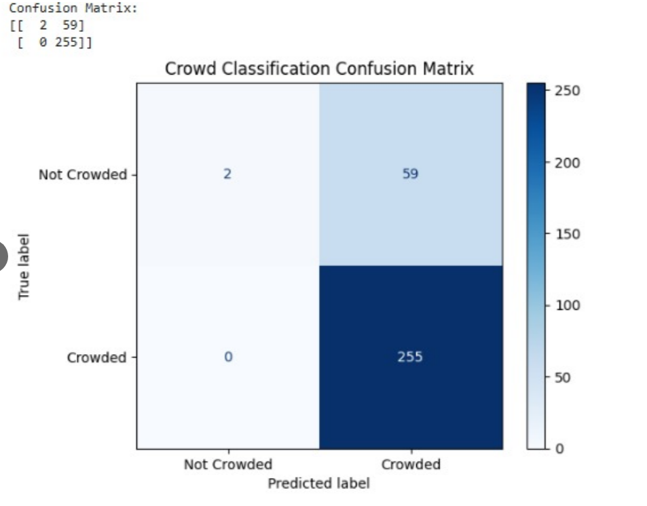

- Confusion matrix showing the classification results of the proposed crowd monitoring system for crowded and non crowded case

Comparative Analysis and Discussion
Most of the existing approaches in crowd counting are predominantly centered on density map estimation rather than real-time monitoring applications. The Multi-Column Convolutional Neural Network (MCNN) introduced a multi-scale convolutional architecture to effectively address the challenge of scale variation [2]. Subsequently, CSRNet enhanced counting accuracy through the incorporation of dilated convolutional layers, which enabled a larger receptive field while preserving spatial resolution [1]. The Switching Convolutional Neural Network further improved adaptability to varying crowd densities by employing specialized regressors that are dynamically selected based on local density characteristics [4], [5]. In addition, adversarial learning-based approaches contributed to improving consistency in density estimation across multiple image scales, thereby enhancing robustness in complex scenarios [6].

More recent methodologies, including SANet and DSSINet, have focused on hierarchical and multi-scale feature integration techniques to improve the representation of crowd density and spatial context [7], [9]. Furthermore, transformer-based models such as RCCFormer have introduced attention mechanisms to capture long-range dependencies, thereby improving feature representation in dense crowd environments [19]. Despite these advancements, the majority of existing methods primarily emphasize improving density estimation accuracy. In contrast, the proposed system shifts the focus toward real-time crowd monitoring and crowd risk classification, thereby providing a more practical and application-oriented solution.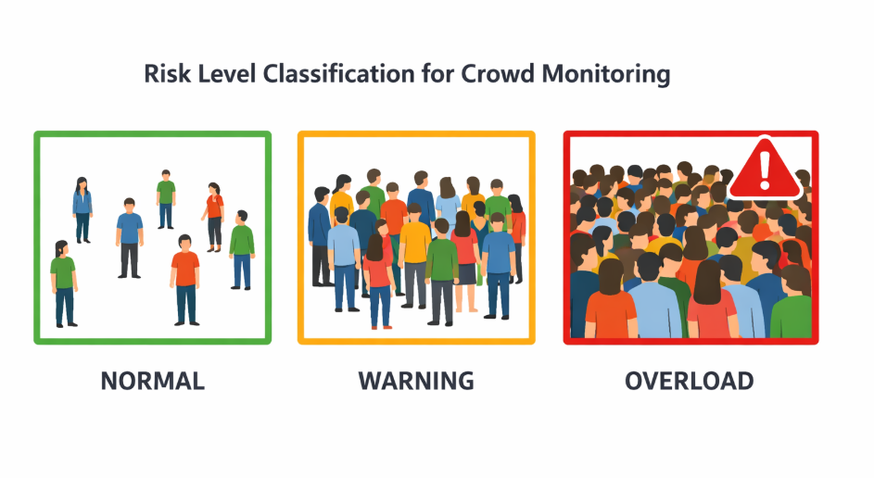
- Visualization of the crowd level risk classification on the basis of the estimated density of the crowd..
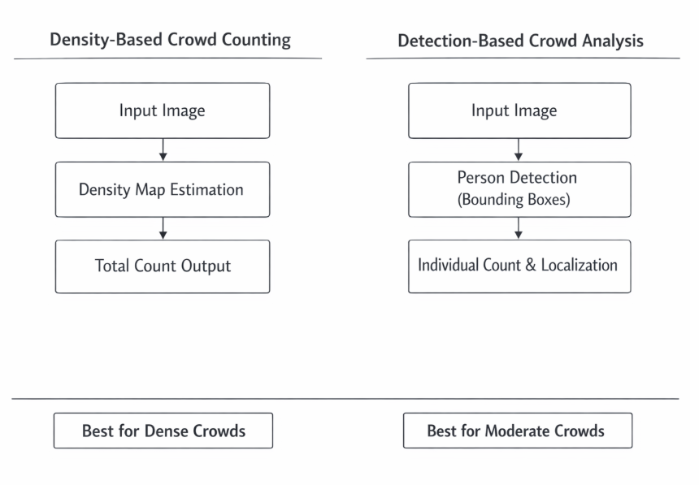
- Conceptual comparison of density-based crowd counting and detection-based crowd analysis approaches
.
Paper | Method | Architecture Type | Dataset | MAE | MSE
[1] | CSRNet | Dilated CNN | ShanghaiTech | 68.2 | 115
[2] | MCNN | Multi-column CNN | ShanghaiTech | 110.2 | 173.2
[3] | Contextual Pyramid CNN | Pyramid CNN | ShanghaiTech | 82.3 | 138.1
[4] | Switching CNN | Multi-regressor CNN | ShanghaiTech | 90.4 | 135
[5] | Switching CNN | CNN with density switching | ShanghaiTech | 90.4 | 135
[6] | Adversarial Cross-Scale | Adversarial CNN | ShanghaiTech | 73.6 | 112
[7] | DSSINet | Scale integration CNN | ShanghaiTech | 60.6 | 96
[8] | Iterative Crowd Counting | Iterative CNN | ShanghaiTech | 69.8 | 117.3
[9] | SANet | Scale Aggregation CNN | ShanghaiTech | 67 | 104.5
[10] | DENet | Detection + Density CNN | ShanghaiTech | 65.5 | 102
[11] | Multipolar Density Map | Multi-scale CNN | ShanghaiTech | 62.3 | 100

[12] | Multitask Point Supervision | Multitask CNN | ShanghaiTech | – | 110.7
[13] | SGANet | Attention CNN | ShanghaiTech | 6.3 | –
[14] | Knowledge Transfer Model | Distillation CNN | ShanghaiTech | ~7–8 | –
[15] | Deep Fusion Network | Fusion CNN | ShanghaiTech | 8.5 | 13
[16] | Multi-Resolution Attention CNN | Attention CNN | ShanghaiTech | 68.3 | 104.9
[17] | DCTNet | Transfer Learning CNN | ShanghaiTech | ~8–10 | –
[18] | Online Knowledge Learning | Knowledge Learning CNN | ShanghaiTech | ~7–10 | –
[19] | RCCFormer | Transformer | ShanghaiTech | SOTA | –

Conclusion

This study was a comparative analysis of nineteen deep learning based approaches for crowd counting and an introduction of a crowd monitoring system based on
YOLOv8 object detection. Existing methods like MCNN, CSRNet, DSSINet and SANet mainly focus on enhancing the accuracy of density estimation by multi-scale learning and advanced convolutional architectures. Although these approaches are proving to yield good performance, one cannot guarantee that they will always suffice for real time application.

In opposition, the proposed method of detection-based identification of individuals and estimating the number of people in a crowd direct, and hence more practical for real-time monitoring scenario. The system was tested on a sheet of data called the ShanghaiTech Part-B dataset, in which crowd conditions were designated as normal or overcrowded. Experimental results showed an accuracy of 81.33%, and this result revealed that the system can effectively identify the level of risk of the crowd.

These results have shown that object detection combined with a simple classifying approach is a good alternative to those density-based methods, and an improvement in terms of interpretation. However, detection-based methods may suffer from over-dense scenes because of occlusion and scale variation as seen in previous studies. Future research could be aimed at combining the density estimation techniques with the detection-based approaches to further enhance the performance in such scenarios.

All in all the proposed system offers a sensible approach for real-time crowd monitoring in the area of balancing accuracy with simplicity and applicability.

References
- Y. Li, X. Zhang, and D. Chen, “CSRNet: Dilated Convolutional Neural Networks for Understanding the Highly Congested Scenes,” arXiv preprint arXiv:1802.10062, 2018.
- Y. Zhang, D. Zhou, S. Chen, S. Gao, and Y. Ma, “Single-Image Crowd Counting via Multi-Column Convolutional Neural Network,” in Proceedings of the IEEE Conference on Computer Vision and Pattern Recognition (CVPR), 2016, pp. 589–597.
- V. A. Sindagi and V. M. Patel, “Generating High-Quality Crowd Density Maps Using Contextual Pyramid CNNs,” arXiv preprint arXiv:1612.00220, 2016.
- D. Sam, S. Surya, and R. V. Babu, “Switching Convolutional Neural Network for Crowd Counting,” in Proceedings of the IEEE Conference on Computer Vision and Pattern Recognition (CVPR), 2017.
- D. Babu Sam, S. Surya, and R. V. Babu, “Switching Convolutional Neural Network for Crowd Counting,” in Proceedings of the IEEE Conference on Computer Vision and Pattern Recognition (CVPR), 2017.
- Z. Shen, Y. Xu, B. Ni, M. Wang, J. Hu, and X. Yang, “Crowd Counting via Adversarial Cross-Scale Consistency Pursuit,” in Proceedings of the IEEE Conference on Computer Vision and Pattern Recognition (CVPR), 2018.
- [Q. Zhang, A. B. Chan, and W. Liang, “DSSINet: Deep Structured Scale Integration Network for Crowd Counting,” arXiv preprint arXiv:1908.08692, 2019.
- L. Liu, H. Lu, H. Zou, H. Xiong, and J. Cao, “Iterative Crowd Counting,” arXiv preprint arXiv:1807.09959, 2018.
- X. Cao, Z. Wang, Y. Zhao, and F. Su, “Scale Aggregation Network for Accurate and Efficient Crowd Counting,” in Proceedings of the European Conference on Computer Vision (ECCV), 2018.
- Z. Liu, J. van de Weijer, and A. D. Bagdanov, “DENet: A Universal Network for Counting Crowd with Varying Densities and Scales,” arXiv preprint arXiv:1904.08056, 2019.
- J. Shi, Q. Liu, and X. Wang, “Learn to Scale: Generating Multipolar Normalized Density Maps for Crowd Counting,” arXiv preprint arXiv:1907.12428, 2019.
- Y. Song, J. Liu, and H. Wang, “Multiscale Crowd Counting and Localization by Multitask Point Supervision,” arXiv preprint arXiv:2202.09942, 2022.
- Q. Wang, J. Gao, W. Lin, and X. Li, “SGANet: Segmentation Guided Attention Network for Crowd Counting,” arXiv preprint arXiv:1911.07990, 2019.
- [14] Y. Liu, M. Shi, Q. Zhao, and X. Wang, “Efficient Crowd Counting via Structured Knowledge Transfer,” arXiv preprint arXiv:2003.10120, 2020.
[15] S. Zhang, H. Li, and X. Yang, “A Deep Fusion Network for Crowd Counting in High-Density Scenes,” International Journal of Crowd Science, vol. 5, no. 2, pp. 120–132, 2021.
[16] Y. Ma, J. Dai, and H. Li, “Multi-Resolution Attention Convolutional Neural Network for Crowd Counting,” Nanyang Technological University Technical Report, 2021.
[17] X. Li, H. Zhang, and Y. Chen, “DCTNet: Deep Crowd Transfer Network for Crowd Counting,” Array, vol. 13, 2022.
[18] Y. Wang, J. Zhang, and L. Li, “Crowd Counting with Online Knowledge Learning,” arXiv preprint arXiv:2303.10318, 2023.
[19] Z. Liu, Y. Zhao, and H. Chen, “RCCFormer: A Robust Crowd Counting Network Based on Transformer,” arXiv preprint arXiv:2504.04935

